**Install docker on EC2 and explore the docker commands (docker images, containers, volumes, network)**

**Step 1 :Created Docker EC2**

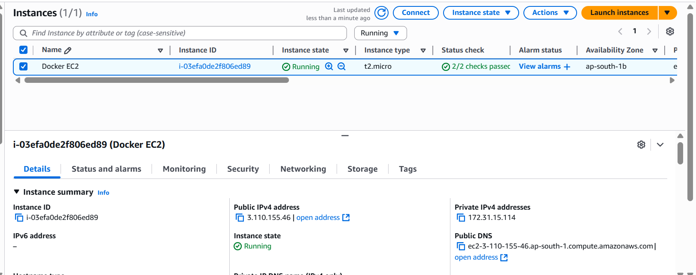

**Step2: Docker image commands**

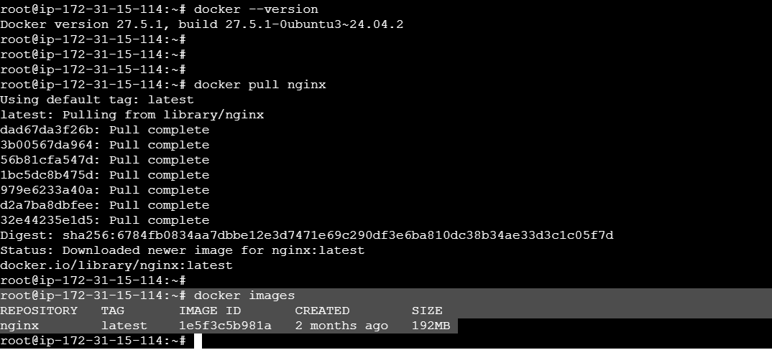

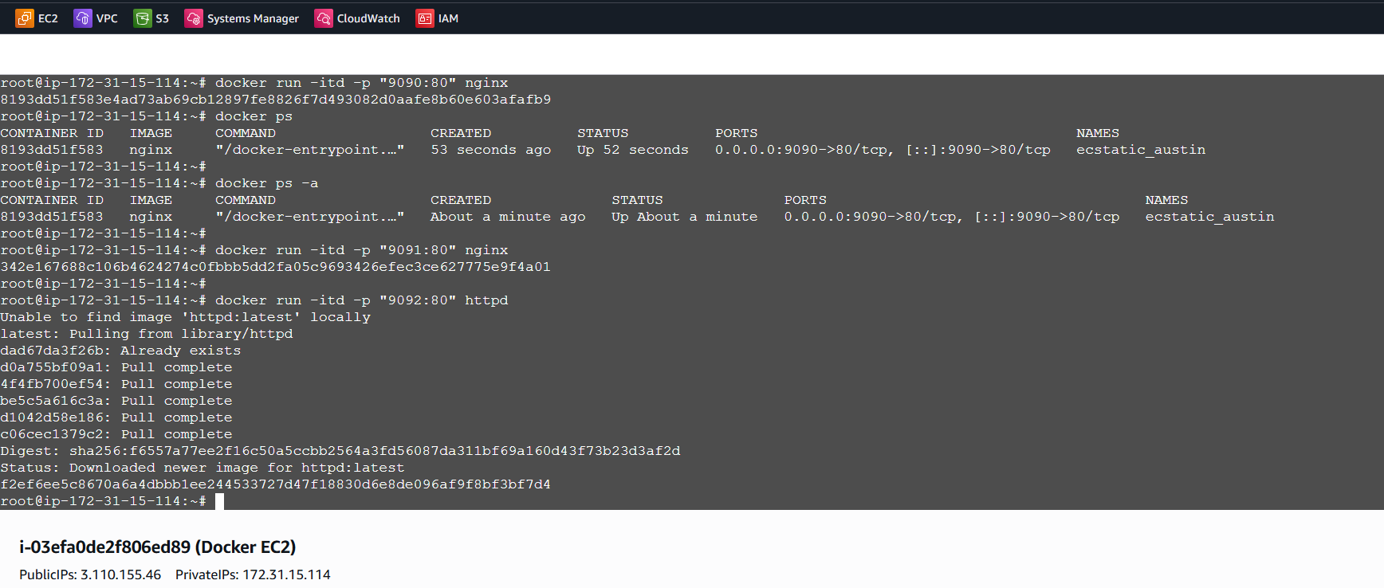

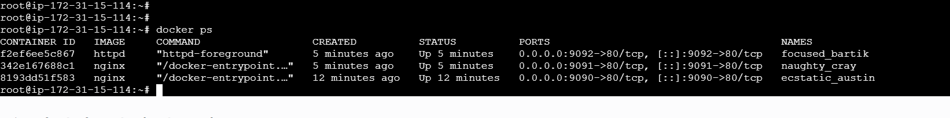

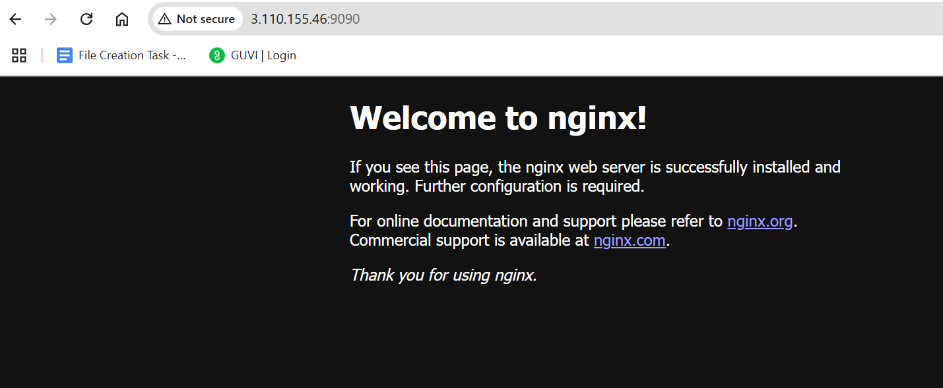

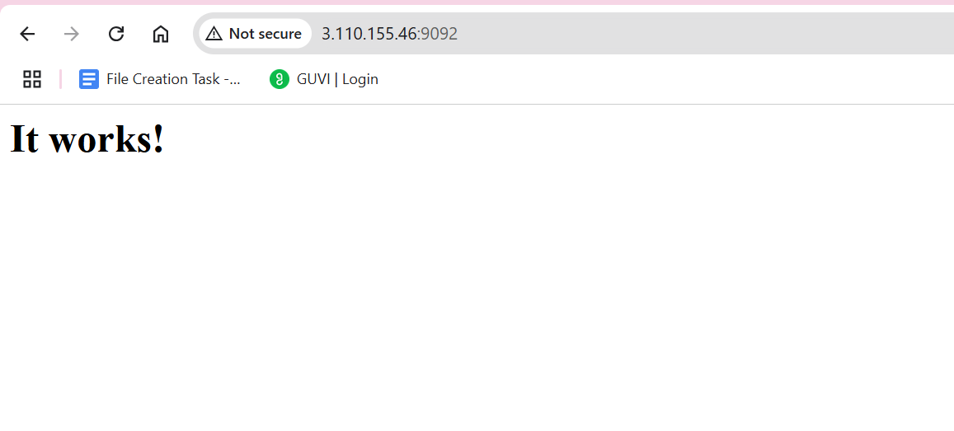

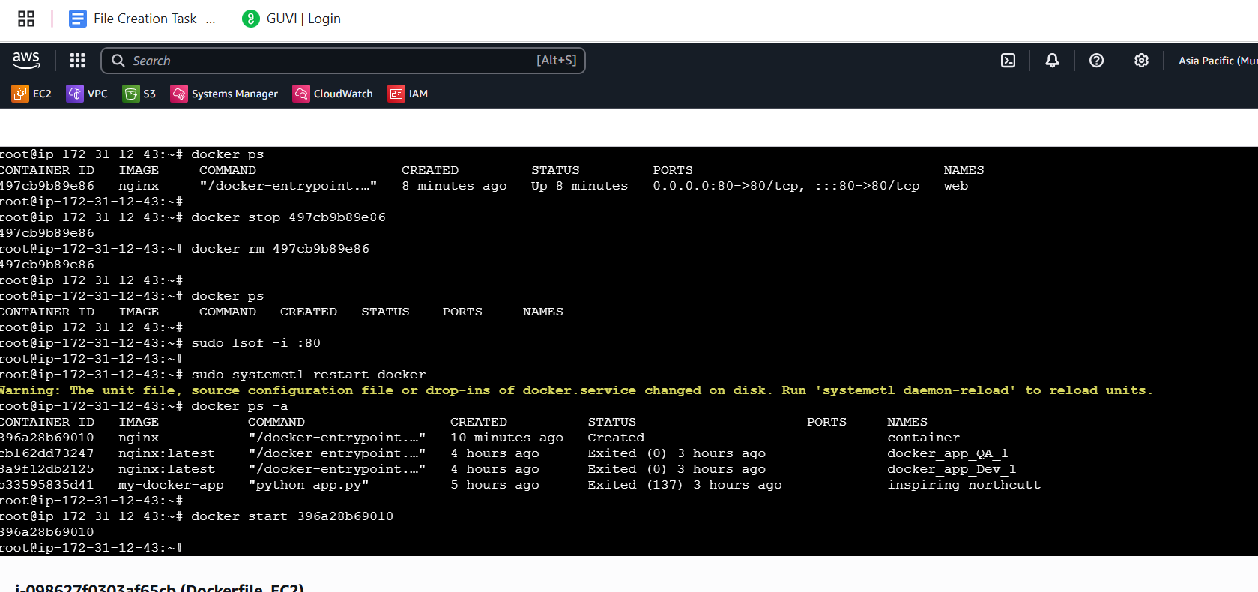

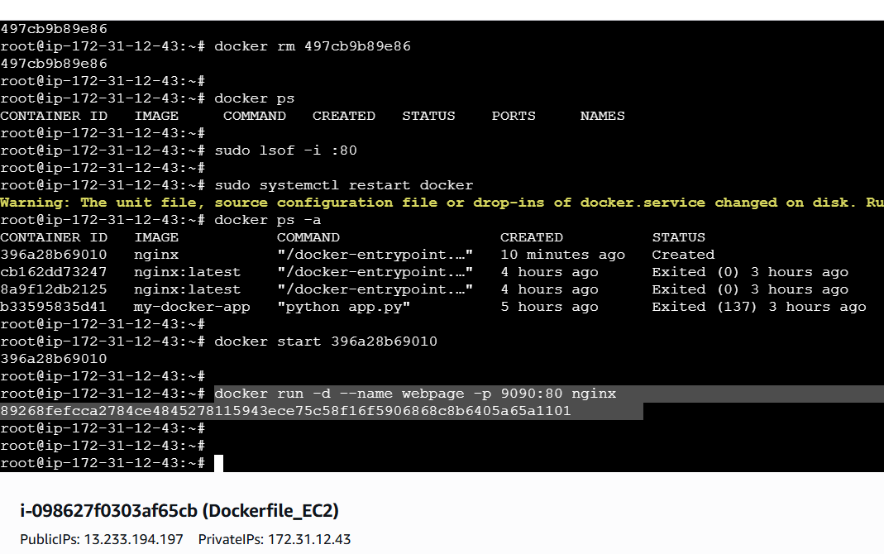

**Docker Volume**

**Docker network  


